*LAB # 03*

arrays in java

# *OBJECTIVE:*

*To understand arrays and its memory allocations*

*LAB task*

1. *. Write a program that takes two arrays of size 4 and swap the elements of those arrays.*

**Code:**

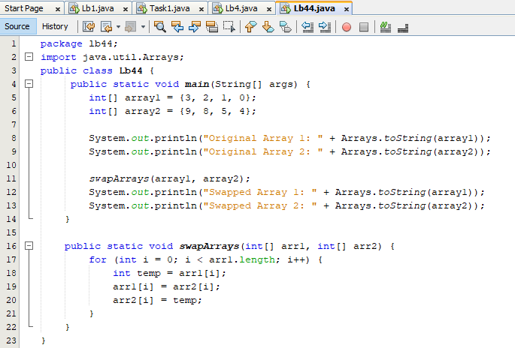

**Output:**

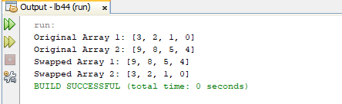

1. *Add a method in the class that takes array and merge it with the existing one..*

**Code:**

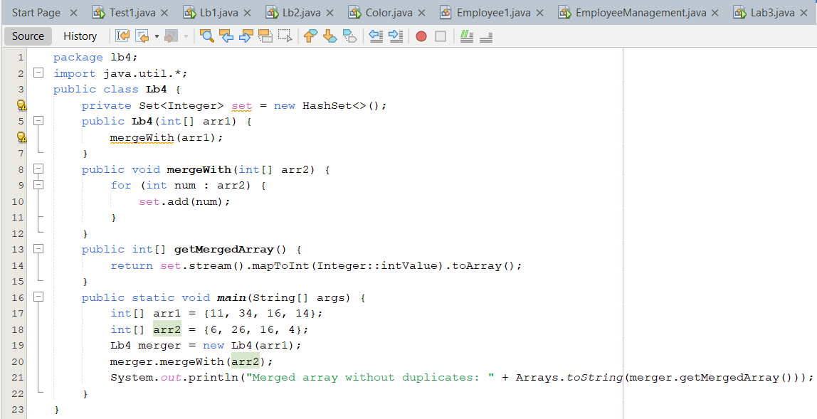

**Output:**

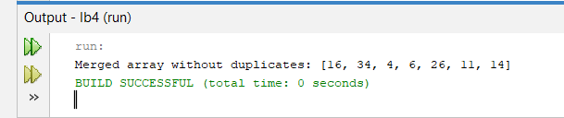

1. *In a JAVA program, take an array of type string and then check whether the strings are palindrome or not.*

**Code:**

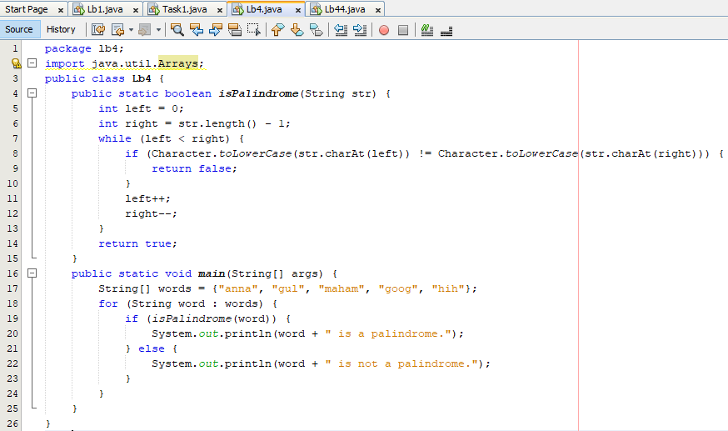

**Output:**

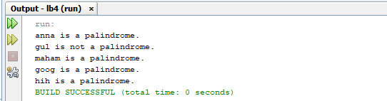

1. *Given an array of integers, count how many numbers are even and how many are odd*

**Code:**

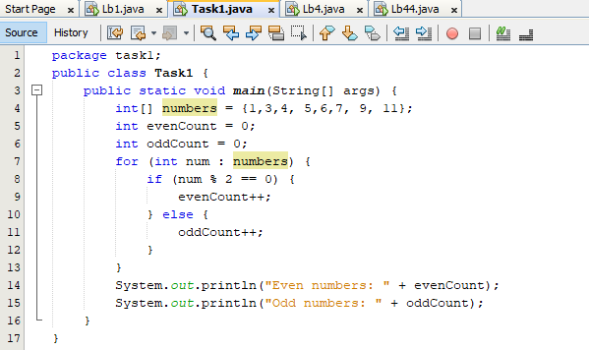

**Output:**

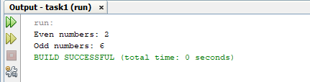

1. *Given two integer arrays, merge them and remove any duplicate values from the resulting array.*

**Code:**

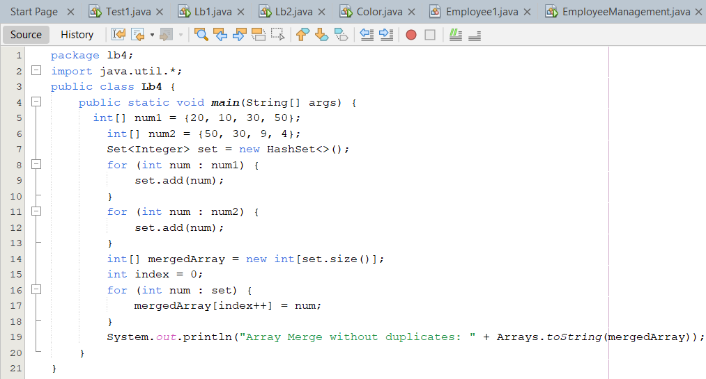

**Output:**

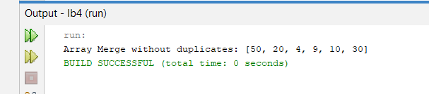

*HOME task*

1. *Write a program that takes an array of Real numbers having size 7 and calculate the sum and mean of all the elements. Also depict the memory management of this task*

**Code:**

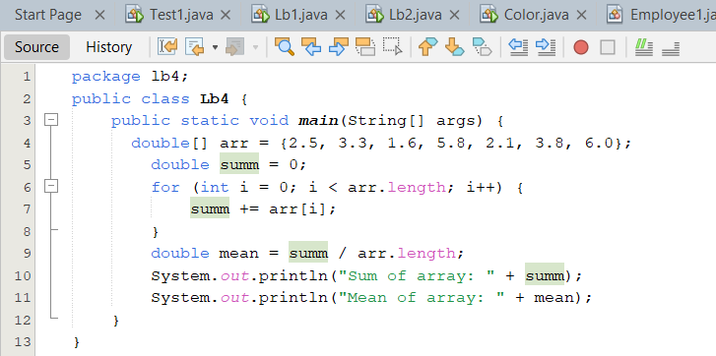

**Output:**

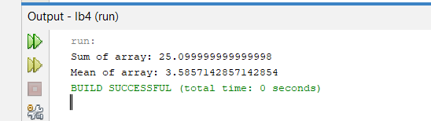

1. *Add a method in the same class that splits the existing array into two. The method should search a key in array and if found splits the array from that index of the key.*

**Code:**

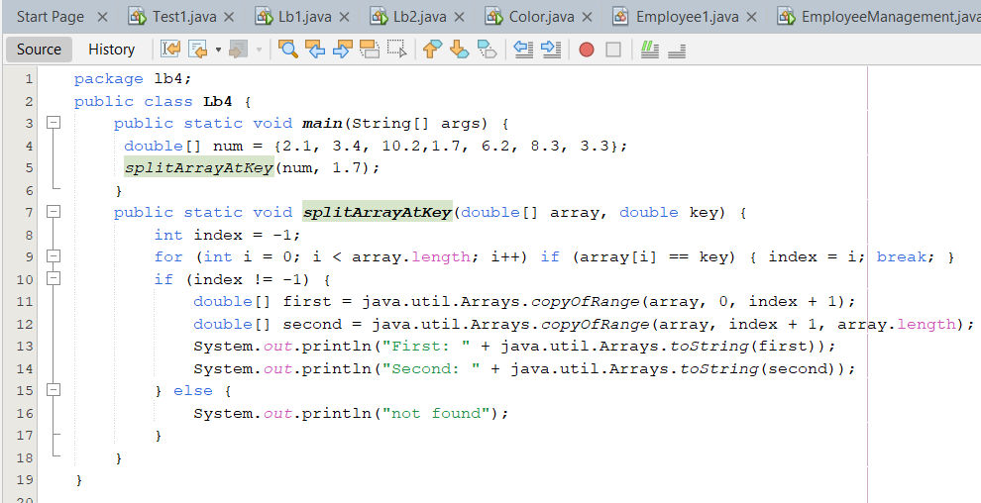

**Output:**

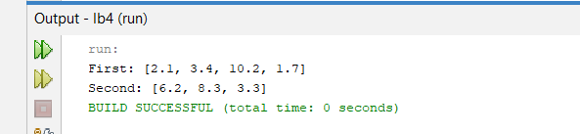

1. *Given an array of distinct integers and a target integer, return all unique combinations of numbers that add up to the target. Each number can be used only once in the combination.*

**Code:**

**Output:**

1. *You are given an array containing n distinct numbers taken from 0, 1, 2, ..., n. Write a program to find the one number that is missing from the array.*

**Code:**

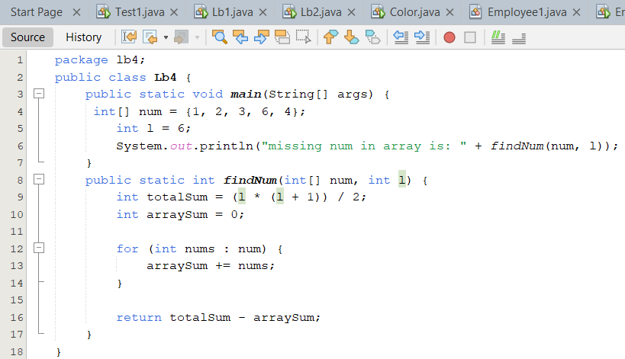

**Output:**

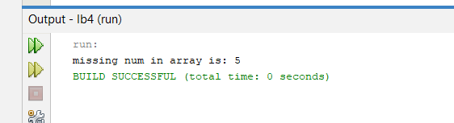

1. *You are given an array of integers. Write a program to sort the array such that it follows a zigzag pattern: the first element is less than the second, the second is greater than the third, and so on.*

**Code:**

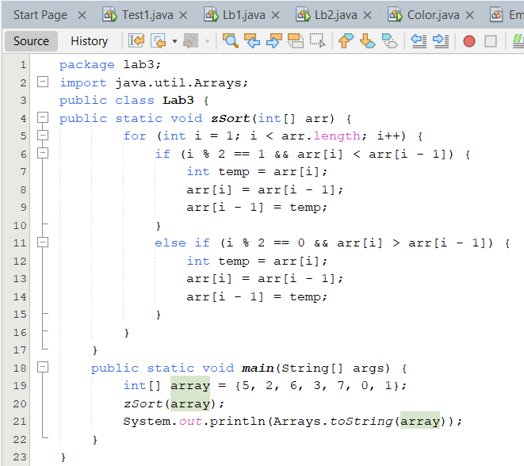

**Output:**

